I’ve been looking at the QLL thickness bias, ${ΔN_{QLL}≝N}_{QLL}\left(model\right)-N_{QLL}(N_{tot})$. Of course, for the 1-variable system, $ΔN_{QLL}=0$. The hope is that for the 2-variable system, $ΔN_{QLL}≈0$. Figure 1 examines $N_{QLL}$ and $ΔN_{QLL}$ for a sample run. Some observations:

- The top row shows that there is an oscillating pattern of the number of steps in a profile (max-min): it rises to a difference of two layers around 5000 $μs$, then flattens out at 10,000 $μs$, then again two layers difference at 15,000 $μs$.
- The middle row reveals that the 5000 $μs$ and 15,000 $μs$ maxima correspond to very different profiles: at 5000 $μs$, the profile is V-shaped, while at 10,000 $μs$, it has inverted to $Λ$-shaped.
- The bottom row shows that the QLL is thicker than equilibrium around the facet center, whereas it is thinner than equilibrium at the corners. This difference is greatest when the surface is transitioning between V-shaped to $Λ$-shaped (i.e., when the surface is flat).
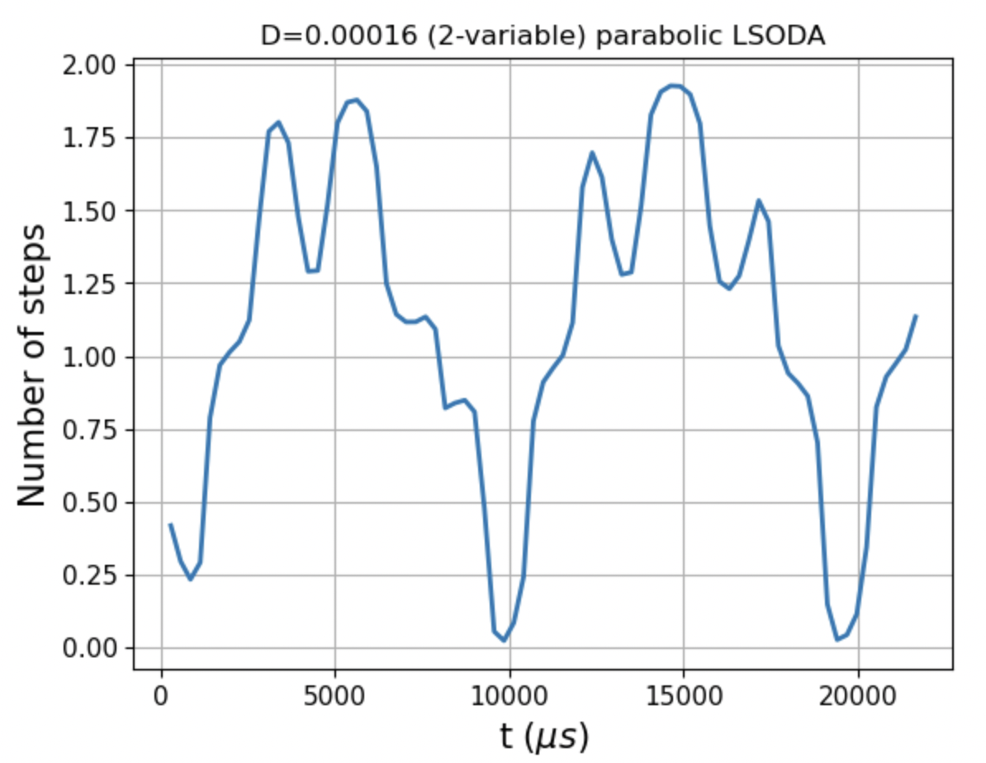
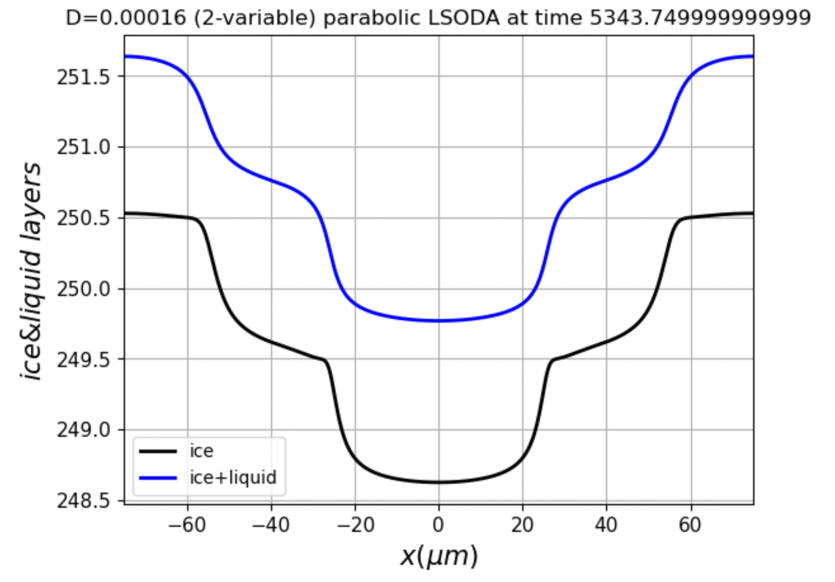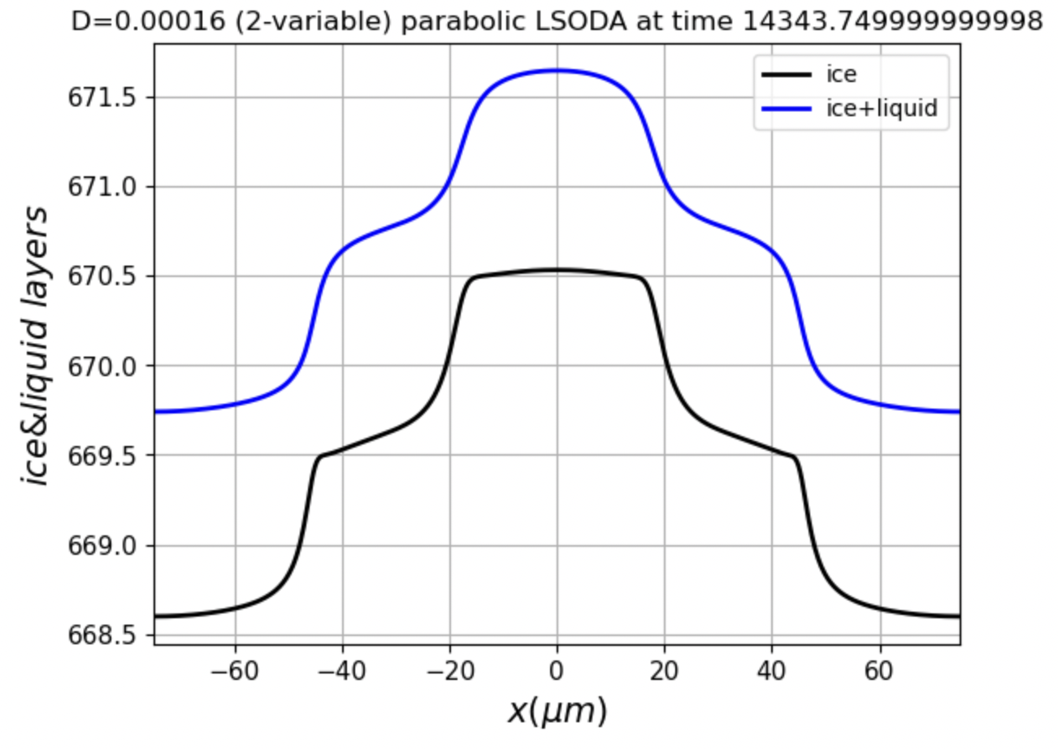
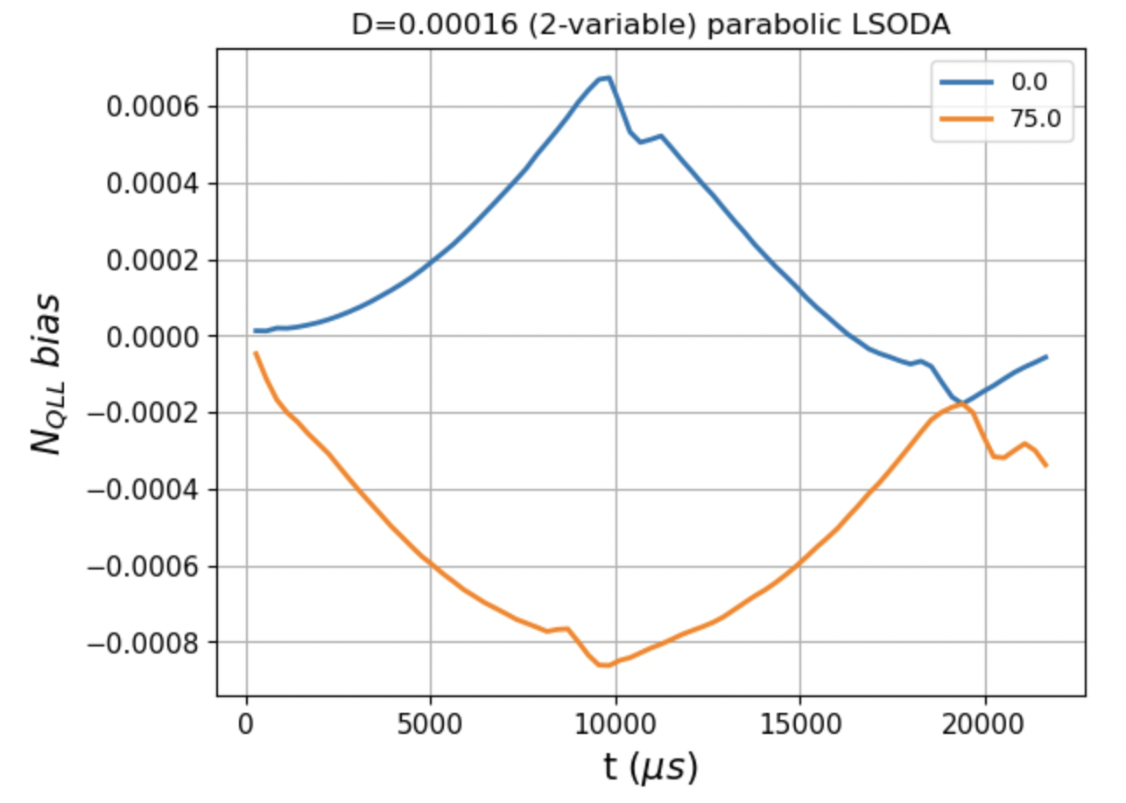
Figure 1. Examination of the quasiliquid thickness bias for a trajectory exhibiting limit cycling. Top row: Number of steps over time; middle row: $N_{ice}$ and $N_{tot}$ profiles at two times during the trajectory; bottom row: QLL bias thickness at two positions of the facet over time.

Figure 2 shows the same things over a longer time. Some observations:

- The profiles still oscillate from V-shaped to $Λ$-shaped and back, but they are distorted from the shapes that appeared nearer the beginning of the trajectory.
- The third row, left, shows that the bias drifts downward over time – toward ever thinner QLL. The third row, right, shows that the drift is still there when we use a (slightly) more sophisticated algorithm, DOP853. This is bad news for the 2-variable system, of course – the QLL should be hovering around the equilibrium value over time.

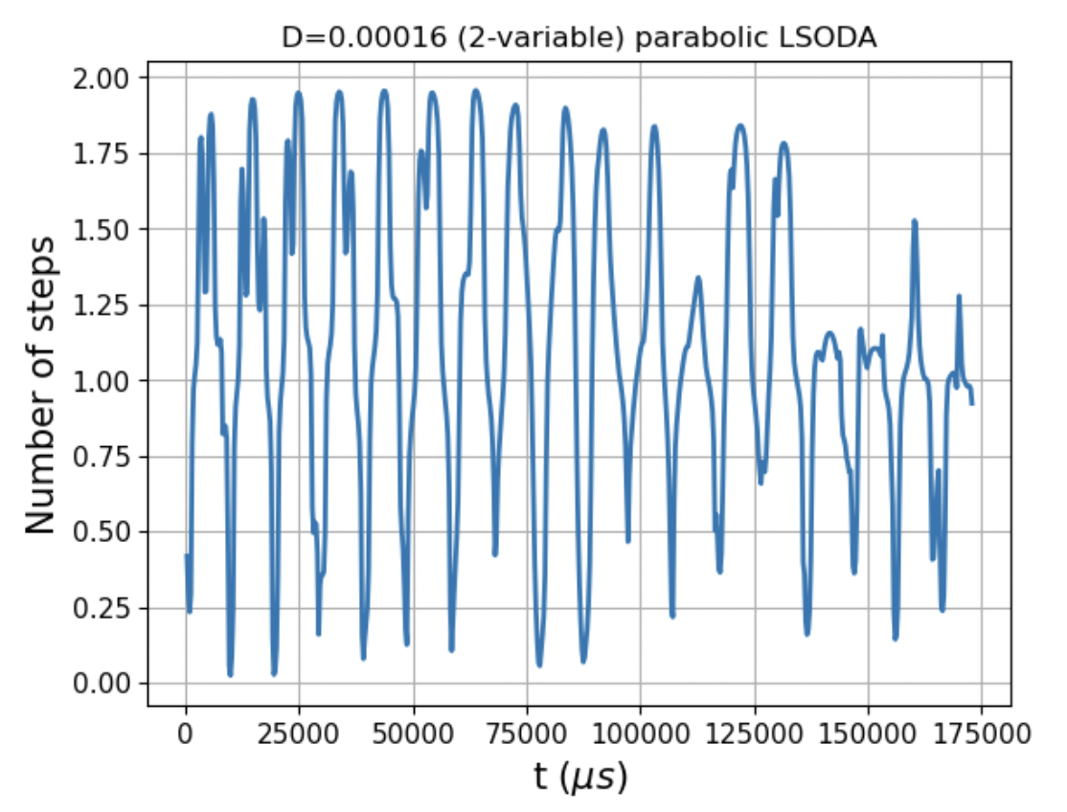
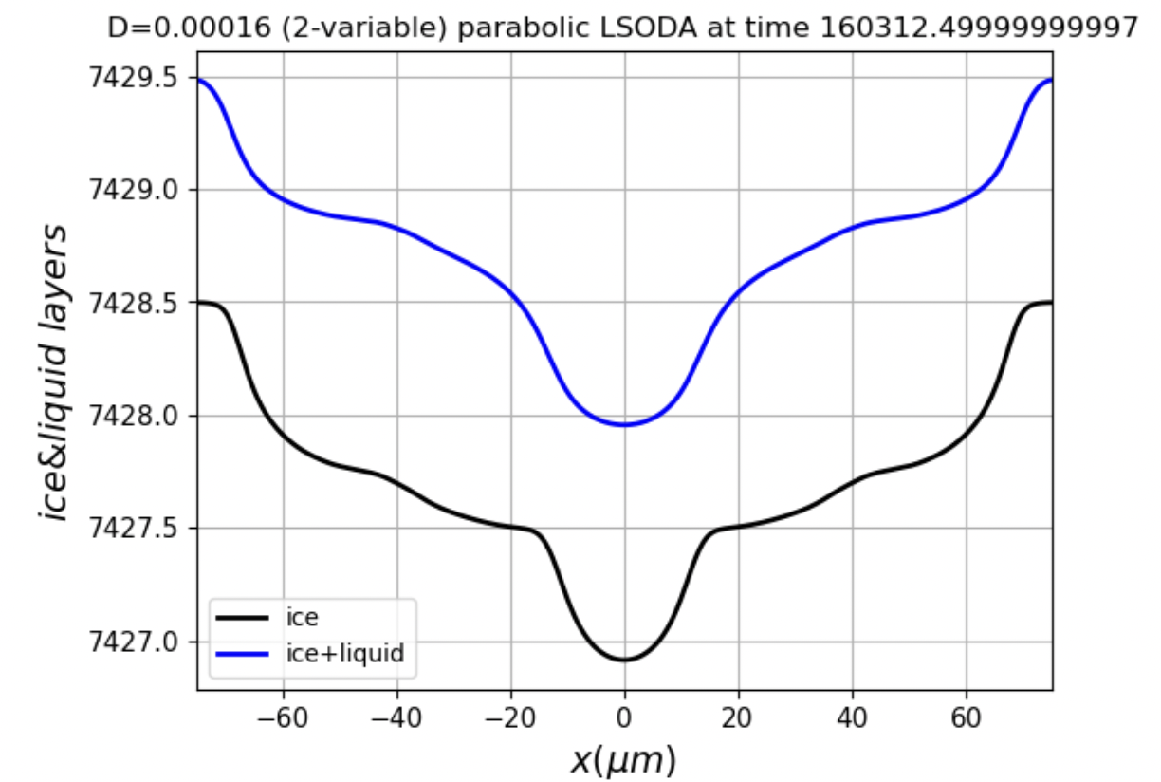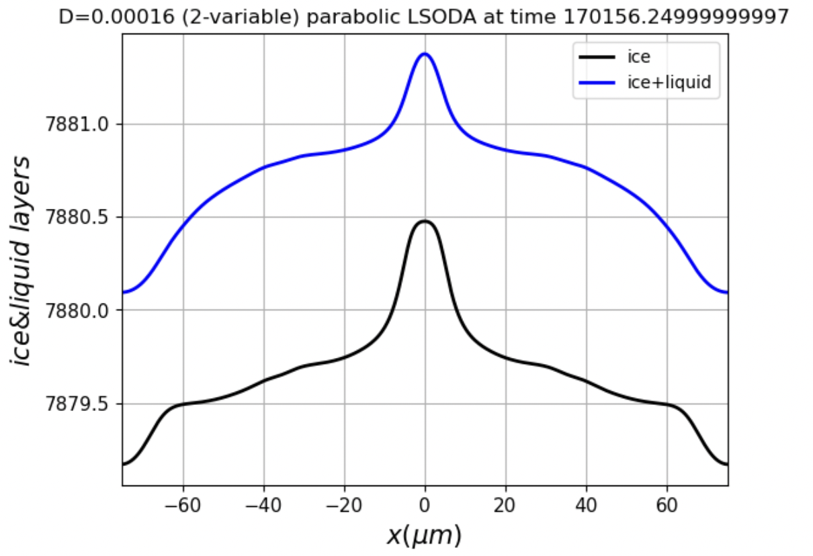
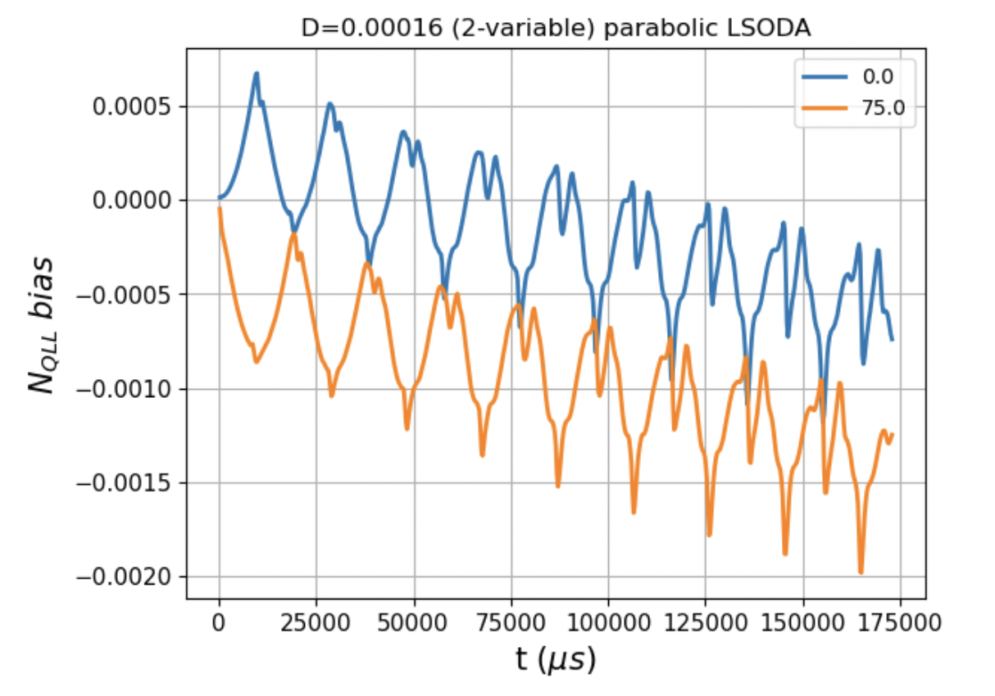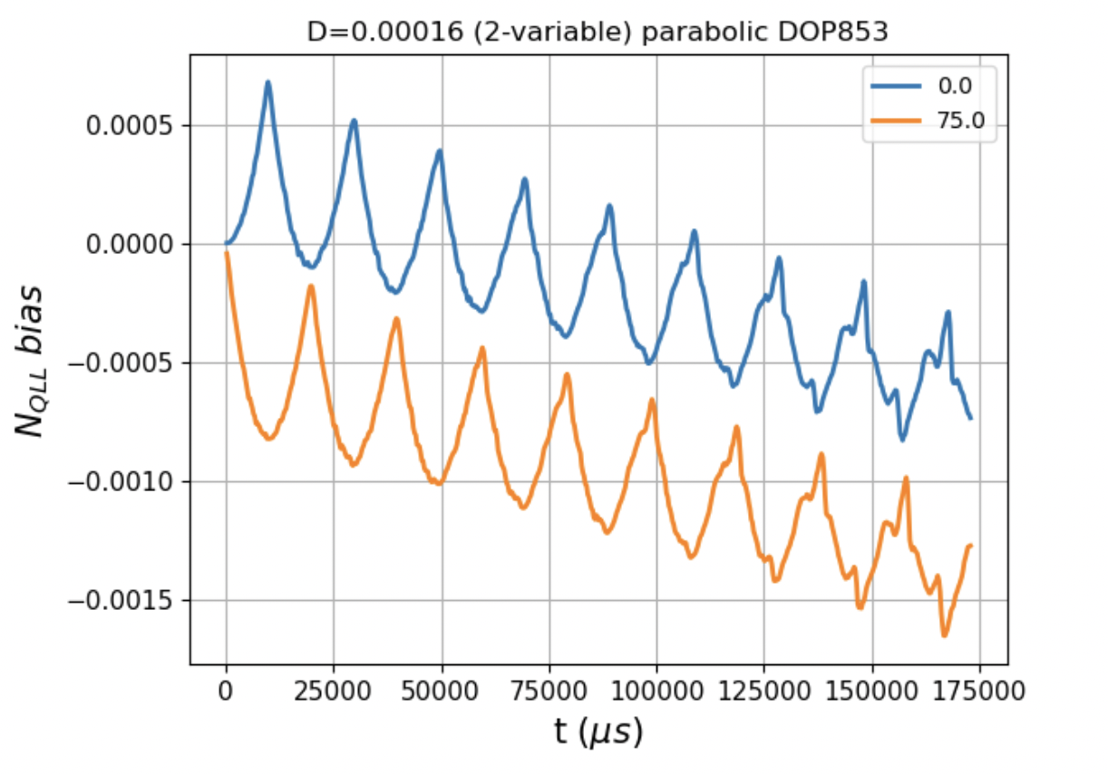
Figure 2. Like Fig. 1, but over a longer time.

